Date | 08/03/2023 | Time | 18:30
Meeting Chairs | Danielle Bagley – Deputy Regional Manager (DB)  Justyna Lisiecka – Practice Manager (JL) | Note Taker | MO
Attendees | SW – Falmouth Road Patient  CL - Falmouth Road Patient  JP – Falmouth Road Patient  Michaela O’Reilly – Assistant Practice Manager (MO)

Agenda Item | Discussion
Agenda | - Introduction and ground rules  - Staff Updates  - Practice updates  - Dr iQ  - Patient Feedback  - AOB
Introductions | Danielle Bagley – Deputy Regional Manager of Southwark  Justyna Lisiecka – Practice Manager of Falmouth Road Surgery  Michaela O’Reilly – Assistant Practice Manager of Falmouth Road Surgery  SW – Long term Patient of Falmouth Road Surgery  CL – Patient for 2 years of Falmouth Road Surgery  JP – Long term patient of Falmouth Road Surgery  DB explained the ground rules of the meeting:  - One person talks at a time – all guests have been placed on mute. Questions and comments can be made in the chat  - Respect all members and their contributions  - Do not use the meeting to raise personal complaints or personal issues  - Allow everyone to contribute
Staff Update for Falmouth Road Surgery | - New Assistant Practice Manager, Michaela O’Reilly  - Departure of Dr Rizvan Ali  - New GPs- Dr Sam Rodgers and Dr Ana Gafita  - New GP from May 2023  - New Nurse Carlisle  - New HCA Sara  - New Regional Nurse Abha  - New Pharmacist Tom  - New GP Assistant Jibran  - New admin Tom, Ethan, Shannida, Halima  - Planned recruitments, Lead GP, 3x FTE GP
Practice Updates | - More F2F GP appointments  - Choose F2F or TC at point of booking  - Planning for bringing back routine pre-bookable appointments  - More Nursing appointments  - New phone system – press one and get a call back to avoid waiting time  - Relocation update  - Additional 3 clinical rooms  - Additional admin office  - New fire system  - CCTV in place around the building
DriQ Statistics | - 11,791 registrations  - Nearly 60,000 online consultations processed  - Nearly 15,500 medication orders  - Patient feedback 4.7/5
Friends and family test | How likely are you to recommend our GP practice to friend and family if they needed similar care or treatment?  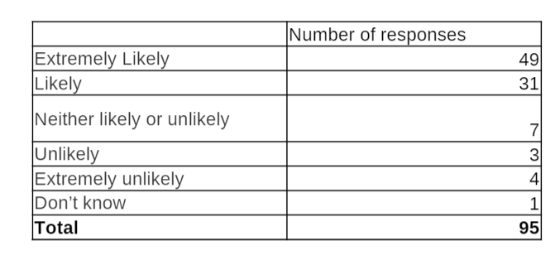  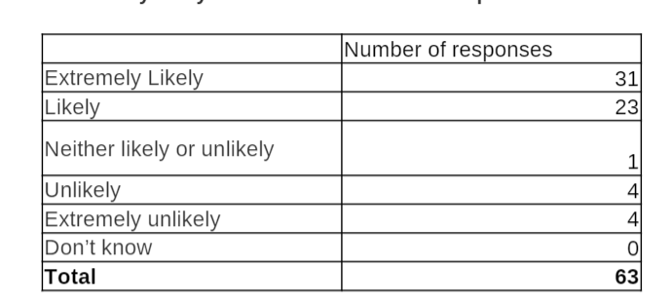
PPG Members Feedback/ Proposals | Staff Feedback  - SW – Carlisle is Marvelous. She helped me with a personal problem and managed to resolve it for me. Laura is wonderful.  - JP – Tom and Ethan are both lovely, Laura is also very nice.  Appointments  - SW and JP both happy with the proposal and works being carried out for more pre-bookable appointments.  - JP – With the time scale of appointments, is it possible to have clinics open later in the evening. Maybe until 7pm?  - JL – This isn’t something we are looking into directly at the moment but is definitely something we can explore.  Health and Safety  - SW – Rough sleepers seen around the building in the evening and over the weekend.  - JL – Police and Local charities are unable to offer much support when contacted without the person being still on the premises. We have previously left notes for the individual to attend the surgery during opening hours for support but this has been unsuccessful. We are unable to refer or ask local charities for help as we have been unable to identify the rough sleepers.  Additional services  - SW – Years ago used to have massage therapist once a week in the practice for Back pain.  - JL – we can refer patients to first contact physio at Extended Primary Care Services at Bermondsey Spa who can either offer treatment in community of refer for further secondary treatment in the hospital.  Referrals Processes  - SW – Unsatisfied with the referral system. Department states they haven’t received referrals.  - JL – We have raised Quality Alerts with the clinics whenever we have had delays with patient referrals, we are currently experiencing issues with the radiology department in particular where patients are advised that the referral was not received by them until it has been vetted by their clinician which can take up to 8 weeks.  Clinical Team Roles  - SW – What is a Pharmacist? What can they do?  - DB – We have a robust training plan for our pharmacists. They can change medication doses, do Long Term Condition reviews such as Asthma, COPD. They specialise in medicine and are able to change and issue new medication.  Dr iQ  - JP – What is DriQ and how does it work?  - DB – DriQ is an app that belongs to the company, it’s something that we have created. You can complete an online consultation which will be picked up and actioned by a clinician the same day. It is open from 7am Monday to Friday and allows patients to access medical help if they are unable to contact us via phone or coming into the surgery.
End of Meeting | Thank you for taking the time to attend. We greatly appreciate all feedback received from our patients.

